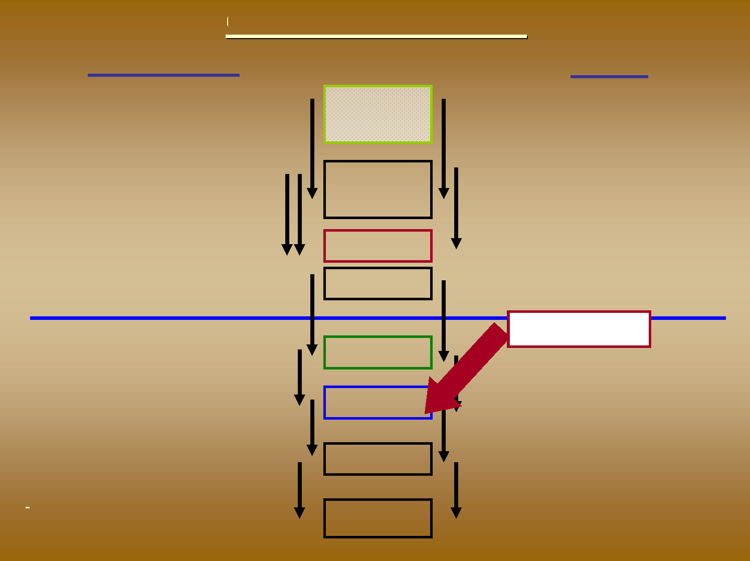
Cocoa Supply Chains
Côte d’Ivoire Ghana
- Small, Family farms (> 750,000) - Independent operation
- Few Cooperatives (< 20% of Crop)
Farmer
- Small, Family farms (> 600,000) - Independent operation
- Few Cooperatives (< 10% of Crop)
- Initial Purchase by Licensed Buyers (LBC’s)
- Ghana Cocoa Board (COCOBOD) and affiliated organizations.
- Quality requirements linked to sales
Collectors
Transporters
- Various Participants, Including International
Companies
Processors
Exporters
- Various participants, including
COCOBOD and international
Companies (not necessarily linked)
- Includes Semi-Finished Goods
- Includes Semi-Finished Goods
Other Beans
- Beans, SF products into Global Market - Further Manufacturing of Products
- Privately Funded operators - Pisteurs, Traitants
- Fewer Quality linkages
Global Market
- Beans, SF products into Global Market
Manufacturers
- Further Manufacturing of Products
- Retail Outlets, Restaurants, small businesses
- Retail Outlets, Restaurants, small businesses
Customers
Consumers
Final Consumer
- Final Consumer

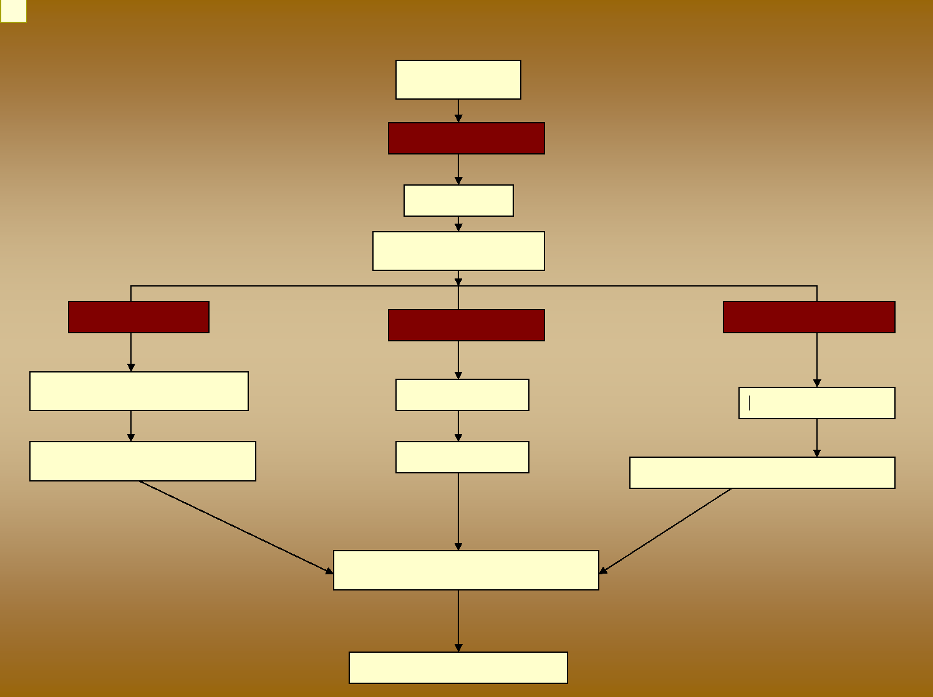
i10
The Market for
Chocolate
Confectionery
Farms
Cocoa Beans
Traders
Cocoa Grinders
Cocoa Liquor
Cocoa Powder
Confectionery Industry
Cocoa Butter
Cosmetics
Food Industry
Chocolate, Confectionery
Cream, Soap
Drink, Ice Cream, Biscuit, etc
Supermarkets and shops
Consumers

Slide 2
i10 Just a thought: This is a good overview slide but perhaps is not easily understood for someone new to cocoa.
Perhaps we can illustrate the end uses rather than have those as text boxes... Have given a try at reorganising in next slide.
isabelle, 11/21/2008

